Mononeel Engineering

Private Limited

# **Introduction**

Founded in 2013, Mononeel Engineering Private Limited is a technology driven company managed by experienced professionals. We are rooted in expertise of manufacture and application of spray nozzles and other accessories. With our expertise in manufacture and extensive domain knowledge, we cater to various industries including Automobiles, Steel, Cement, Pharmaceutical, Chemical and Paper.

The aim of our company is customer satisfaction. We ensure products with precision and quality within the stipulated time. We provide a good technical support for our products along with the requisite after sales service. All this is ensured at an affordable price.

Our goal is to be an efficient manufacturing & consulting organization, providing innovative business solutions to our clients. We believe the right way to help ourselves is by helping the customers. And we do our best to achieve that.

# **Camlock Filter**

MNCC Camlock fitting are ideal solution for fitting spray pipes and manifolds in pre-treatment lines in Paint application for automotive Industries. These Couplings are available with BSP (F) end connections

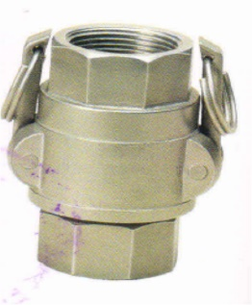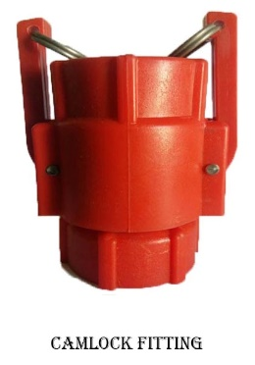

Material of Construction

* GRPP: Glass Fiber reinforce Polypropylene
* SS: 304 Stainless Steel

|  |  |  |  |
| --- | --- | --- | --- |
| **Product Code** | **Size** | **Length** | **Width** |
| MNCC 0025 | 1” | 100 | 75 |
| MNCC 0032 | 1 ¼” | 100 | 75 |
| MNCC 0040 | 1 ½” | 115 | 90 |
| MNCC 0050 | 2” | 115 | 90 |

# **Pipe Support**

MNPS Pipe Support offer an easy and convenient solution for holding the riser pipes in the tunnel of the pre-treatment plants, while making the maintenance operation faster. The spring holders can accommodate both steel as well as plastics pipes, two springs are provided for holding the pipe.

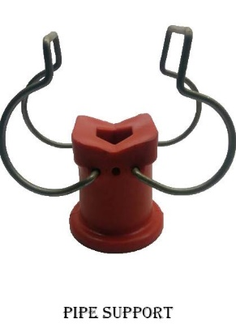 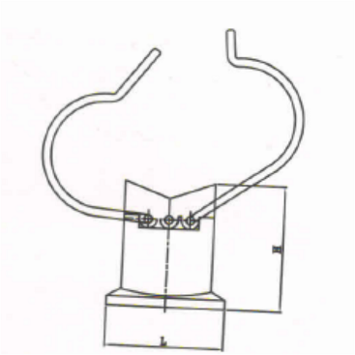 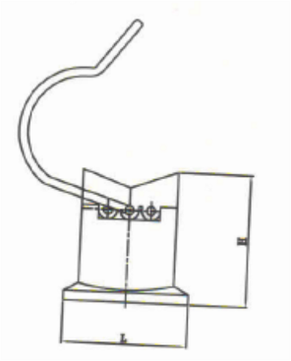

Material of Construction

* Body : GRPP - Glass Fiber Reinforced Polypropylene
* Spring : Stainless Steel (Heat treated)
* Nut with Bolt : SS

|  |  |  |  |  |
| --- | --- | --- | --- | --- |
| **Product Code** | **Size** | **Spring Diameter MM** | **Height MM** | **Nut with Bolt** |
| MNPS 0025 | 1” | 25 | 50 | M 10/ 50 |
| MNPS 0032 | 1 ¼” | 32 | 50 | M 10/ 50 |
| MNPS 0040 | 1 ½” | 40 | 50 | M 10/ 50 |
| MNPS 0050 | 2” | 50 | 50 | M 10/ 50 |

# **End Cap**

MNEC End Cap suited for closing the riser pipes and manifolds in the surface treatment plants. These are molded design in reinforced Polypropylene material.

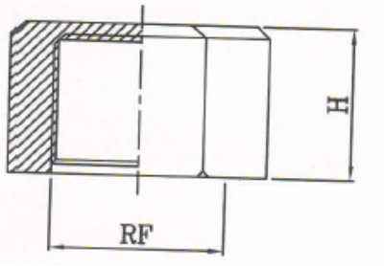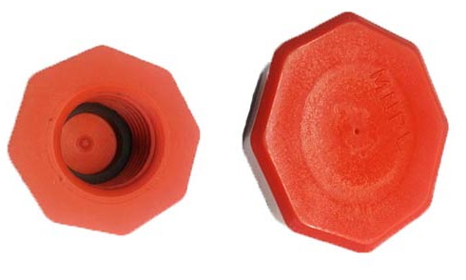

Material of Construction

* Body : GRPP - Glass Fiber Reinforced Polypropylene

|  |  |  |
| --- | --- | --- |
| **Product Code** | **Size** | **Height MM** |
| MNEC 0025 | 1” | 30 |
| MNEC 0032 | 1 ¼” | 30 |
| MNEC 0040 | 1 ½” | 30 |

# **Mixing Educators**

MNME Mixing Educator is a device which mixes two liquids of different flow rates giving a solution of desired flow rate. Educators are made using a venturi design. It enables small pumps to circulate large volumes of tank solution. When pumping is used for solution agitation, the use of an educator will circulate four to five gallons of solution in the tank for every one gallon you pump

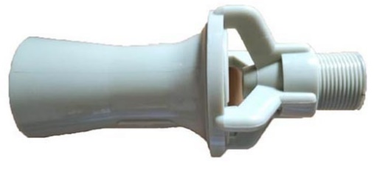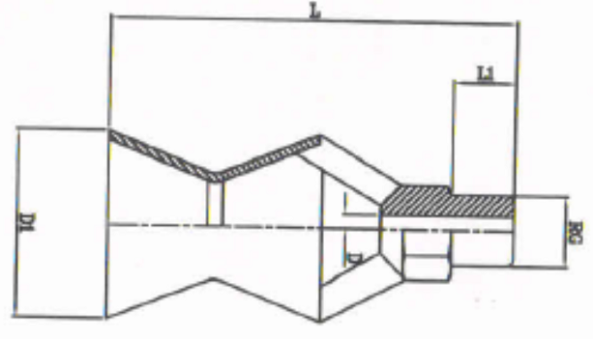

Material of Construction

* GRPP - Glass Fiber Reinforced Polypropylene
* SS – 304 / 316 Stainless Steel

|  |  |  |  |  |  |  |  |  |  |  |  |
| --- | --- | --- | --- | --- | --- | --- | --- | --- | --- | --- | --- |
| **Product Code** | **End Connection** | **D** | **D1** | **L** | **L1** | **WS** |  | | | | |
| 1.00 | 2.00 | 3.00 | 4.00 | 5.00 |
| MNME 2016 | 3/8” | 4.4 | 45 | 98 | 15 | 22 | 12 | 16 | 20 | 23 | 26 |
| MNME 2024 | 3/8” | 5.4 | 45 | 98 | 15 | 22 | 17 | 24 | 30 | 35 | 39 |
| MNME 2033 | 3/8” | 6.4 | 45 | 98 | 15 | 22 | 23 | 33 | 40 | 46 | 52 |
| MNME 2041 | 3/8” | 7.1 | 45 | 98 | 15 | 22 | 29 | 41 | 50 | 58 | 65 |
| MNME 2049 | 3/4” | 7.8 | 60 | 132 | 20 | 30 | 35 | 49 | 60 | 69 | 77 |
| MNME 2057 | 3/4” | 8.4 | 60 | 132 | 20 | 30 | 40 | 57 | 70 | 81 | 90 |
| MNME 2065 | 3/4” | 8.8 | 60 | 132 | 20 | 30 | 46 | 65 | 79 | 91 | 102 |
| MNME 2088 | 3/4” | 9.8 | 60 | 132 | 20 | 30 | 62 | 88 | 108 | 125 | 140 |
| MNME 2097 | 3/4” | 11 | 60 | 132 | 20 | 30 | 68 | 97 | 119 | 137 | 153 |
| MNME 2113 | 3/4” | 11.9 | 60 | 132 | 20 | 30 | 80 | 113 | 138 | 159 | 178 |

# **Swivel Pipe Clamps – Spring Type**

MNSC Pipe Clamps are easy and efficient method for fitting the nozzles in paint shop applications. These clamps use the retaining caps, ball-joint and O-ring. The profiles spring holder allows quick and easy fitment of the clamp on to the pipe, without using any tools.

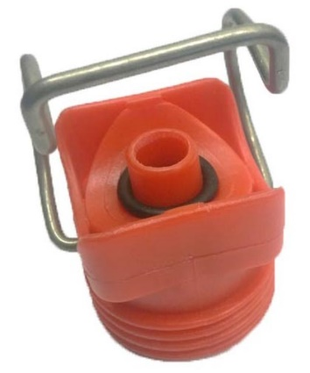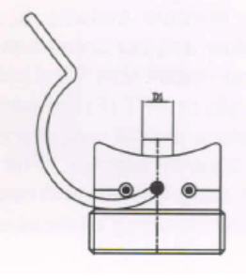

Material of Construction

* Body : GRPP - Glass Fiber Reinforced Polypropylene
* Spring : Stainless Steel (SS)

|  |  |  |
| --- | --- | --- |
| **Product Code** | **Size** | **Outside Dia MM** |
| MNSC 0025 | 1” | 33.4 |
| MNSC 0032 | 1 ¼” | 42.2 |
| MNSC 0040 | 1 ½” | 48.0 |